**New Codington Festival Online Project –**

**Master Practice Primer**

## Table of Contents

Master Practice Primer Introduction 3

Defect Management 4

Peer Review 11

Status Reporting and Meetings 15

# Master Practice Primer Introduction

## Practice Primer Overview

This primer will:

* Provide an overview of the practices and recurring activities that will occur on the New Codington Festival Online Project
* Support Accenture personnel of all workforces to consistently perform recurring and common management and development processes.
* Give the steps to follow to complete these activities during the simulation.

## Practices Covered

The following practices performed during the New Codington Festival Online Project are covered in this primer:

* Defect Management
* Peer Review
* Status Meeting and Reporting

## Instructions for Use

It is highly recommended for the reader to go directly to the section that explains the process or practice that will be performed by the team.

# Defect Management

## Introduction

This section provides directions on Defect Management, which is the process of capturing, reviewing, assigning, fixing, deferring, rejecting and closing defects during certain stages of the software development lifecycle. The same basic defect management process can be followed for all test stages and for all defect types.

A defect is any deviation from the end client requirement that manifests during a project. In other words, it is a gap between the actual and expected results, where expectations are set by client requirements.

Below are the Defect Management activities that will be performed by the team lead/developers during Module 38 and 47.

## Practice Flow Diagram

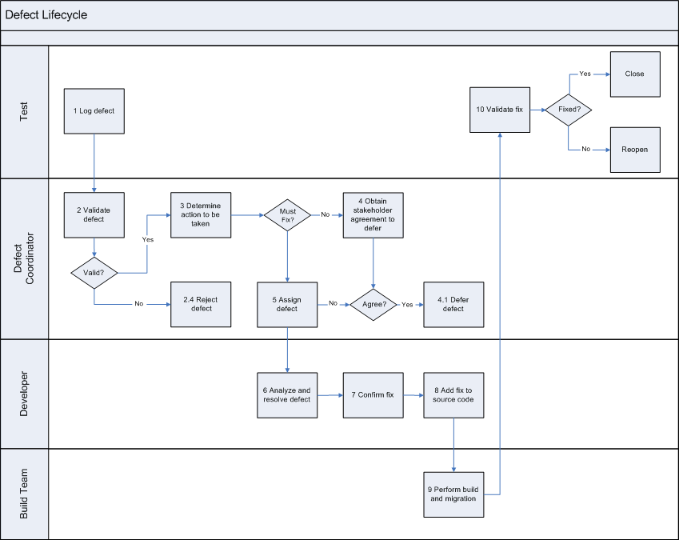  
  
**Key:**

Team Lead Actions

Developer Actions

## Activity Instructions

**Note:** For a summary on what status values are appropriate and legal for a defect during the lifecycle, see the diagram in the ‘Defect Lifecycle’ section below. The steps below do not reflect the entire lifecycle; they only reflect the actions with which the Team Lead and Developer role are actively involved. See the Practice Flow Diagram above for a summary view of these actions.

**Note**: Step numbers below match those in the ADS Practice for Defect Management. Some of the steps are out-of-scope for this project, so they have been left out in order to focus on required actions.

| **Step** | **Details** |
| --- | --- |
| 1. Download a copy of DefectList_FERS_R1_<<Team Name>>.xlsx. | The test team will provide a list of current defects in the application via email to the Team Lead. The Team Lead will use this list to track the status of all defects for this release. |
| **ADS Practice steps:**  2.1. Review defect for completeness and clarity. | Set status of defect to **05 - Validation In-Progress.** The Team Lead reviews any newly logged defects and verifies that appropriate information has been recorded, including:   * All mandatory fields are appropriately completed. * Steps for defect recreation are provided. * Screen shots of any error messages are included as attachments. * Any error logs captured by the test team are referenced or attached. * Any specific application configuration or scenario that causes the defect to occur should be captured. * Any specific data conditions (database values) that cause the defect to occur should be captured. * The priority of the defect has been correctly assigned by the originator of the defect.   If information is missing or ambiguous:   * Set the Assigned To field to ‘**Test** **Team**’ * Set the status to **99 - Request more information** and request additional information in the Comments field, being as specific as possible. |
| 2.3. Determine if the defect is a duplicate. | Once you have reviewed the defect, determine if the same defect has already been recorded.   * If yes, set the status of the defect to **97 – Rejected: Duplicate**. * If not, continue to next step |
| * 1. Check that the defect is valid. | Examine if the defect is an issue due to functional, technical, or human capital problems not related to requirements.   * If it is not valid, set the status of the defect to **98 –** **Rejected: Out of Scope**. * If not, continue to next step. |
| * 1. Confirm the priority of the defect. | Review and adjust the priority of new defects based on the defect standards discussed in Modules 15, 16 and 17, review the application requirements and discuss them with the team. |
| 3.1. Conduct an impact analysis. | Perform an initial impact assessment to determine the following:   * Rough cost (how many hours to fix?) * Impact to schedule * Impact on other components in the product |
| 3.2. Determine if the defect must be fixed for this release. | Team Lead will reach out (if needed) to the Development Team Manager to determine if the defect needs to be deferred.  If yes, set the status of the defect to **94 - On Hold**.  It will get reviewed by the Development Team Manager with the Client to determine if will be set to **Deferred**. |
| 5.3. Assign the defect to a resource. | Update the **Assigned to** field with the name of the team member who will fix it based on skill set, and who is available on the team. |
| 6.1. Recreate Defect. | Set status of the defect to **10 - Under Review.** Following the steps documented in the defect record, see if you can recreate the same results reached by the test.  If you cannot recreate the defect:   * Set assigned to field to ‘**Test Team**’ * Set the status to **99 - Request more information** and request additional information, being as specific as possible in the Comments field. * Discuss the defect with the Team Lead. If needed, communicate need for more information to test team. |
| 6.2. Determine possible causes. | Confirm that the defect is related to requirements, rather than environment, data, script, or human error.  If related to requirements, analyze the defect for possible causes.  If environment, data, or human error (data not valid, mistake in script or mistake in order of execution of activities by tester):   * Set the status of the defect to **94 - On Hold** * Assign the defect to the Test Team. * Record the defect as an issue in the Comments field. |
| 6.3. Determine resolution options. | Many defects, upon analysis, will have a straightforward resolution. Some, however, may require a deeper evaluation of options. In those cases:   * Examine the options for resolving the defect. * Assess the time to complete for each resolution option. * Assess the impact to other components. * Escalate your evaluation to the Team Lead if the impact is high or if the fix calls for a large regression test. |
| 6.4. Fix the defect. | Set the defect status to **20 - Fix in Progress.** Do what you have to do to fix the error, in accordance with your team’s processes and standards. |
| 7.1. Determine the level of testing required. | Consider how much testing is needed to make sure the fix works.  In particular, what other components need to be tested to make sure they still function as defined in the requirements (i.e. regression test).  In particular, how much unit and assembly testing are needed? |
| 7.2. Conduct component test using appropriate test scripts. | Set the status of the defect to **30 - Dev Team Testing.** Execute the unit/component test to ensure the defect is resolved and the fix has not introduced additional errors. (Use stubbed code, test the updated code in isolation)  If a failure occurs return to step **6.1 Recreate Defect.** |
| 7.3. Conduct assembly readiness test using appropriate test scripts. | Ensure the status of the defect remains **30 - Dev Team Testing.** Execute an assembly readiness test to ensure the defect is resolved and the fix has not introduced additional errors. (Replace stubbed code with application source code to test the update code with the rest of the actual components.)  If a failure occurs return back to step **6.1 Recreate Defect.** |
| 8.1. Check-in tested code. | Check your code into the code repository. |
| 8.2. Update the defect record with resolution documentation. | This documentation should include the following (in the Resolved Date and Resolution Description fields):   * Name of individual completing resolution * Cause of the problem * Date of resolution * Resolution of the problem * Modules changed * Testing performed |
| 9.1. Rebuild project. | **Tip**:  Wait until a series of fixes are complete before executing a new build of the product.  Confirm that the build was successful. |
| 9.4. Update defect status to indicate ready for retest. | Update the status to **40 - Ready for Retest** for build and migration. Resend an updated defect list and notify the test team that application is ready to be retested. |

## Defect Lifecycle

The following diagram depicts the valid states, state changes, and events that can cause the state changes, for a defect lifecycle. The states are written in the box, the arrows show the legal state changes and the phrases written along the arrows represent the events.

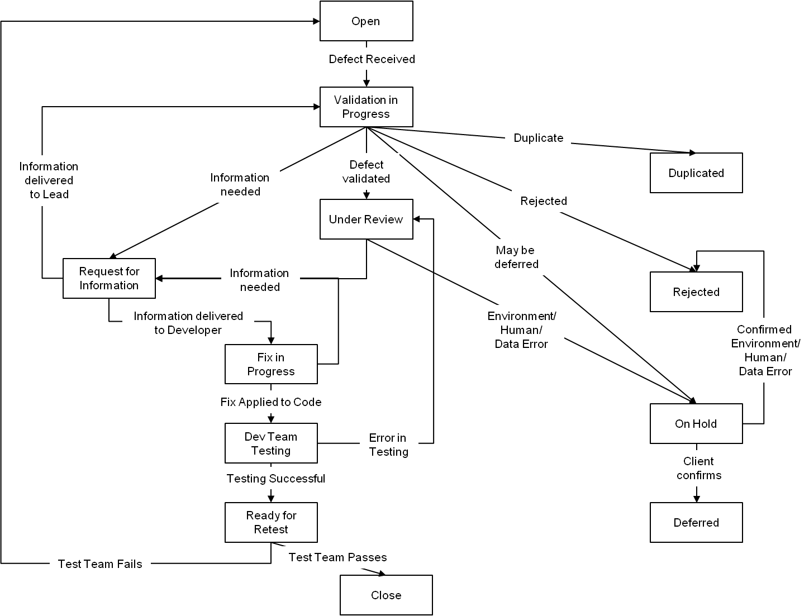

# Peer Review

## Introduction

Peer review is the methodical review of a work product by a person other than the work product owner. Its output is the confirmation of a work product’s quality, and the documentation shows non-compliance with standards and required design changes.

Peer review activities will be performed by the team in modules 32, 35, and 38.

In this section, peer review is described as two main activities: Review Activities and Fix and Follow-up Activities. The following practice flow diagram depicts the Peer Review process.

## Practice Flow Diagram

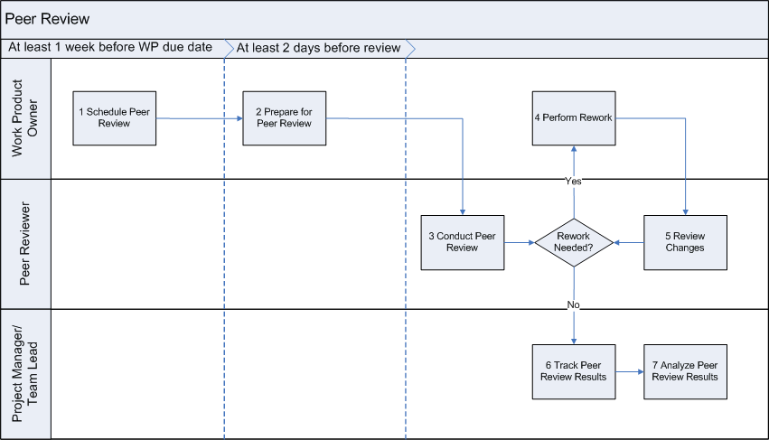

**Key:**

Review Activities

Fix and Follow-up Activities

## Activity Instructions

|  |  |
| --- | --- |
| **Step** | **Details** |
| **Review Activity Steps** | |
| * 1. Identify the work product(s) to be peer reviewed. (WP Owner) | Know clearly which deliverable(s) will be peer reviewed. Make sure to confirm the review method (reviewer and author together or reviewer alone), which peer review criteria will be used, and other requirements. |
| * 1. Identify the peer reviewer for the work product(s). (WP Owner/Team Lead) | Either the WP Owner can find a peer reviewer, the Team Lead can assist in finding a team member to review the deliverable, or the Team Lead can complete the peer review. |
| * 1. Schedule the peer review for the identified work product(s). (WP Owner) | Schedule the review well in advance to allow enough time for preparation, execution, and rework. |
| 2.1. Check the readiness of planned work product(s) for peer review. (Reviewer) | Check to see if the selected, planned work product(s) are ready to be peer reviewed. If the work product is not yet complete, make sure it will be completed before the review's due date. If a work product’s completion is at risk of not hitting the due date, escalate via the appropriate escalation mechanism. |
| 2.2. Prepare peer reviewer(s) for the review. (WP Owner) | Brief the peer reviewer(s) selected for this peer review using their preferred communication channel.  Send/explain the following information to peer reviewer(s):   * Work product to be peer reviewed * Where to find the work product (in code repository – Eclipse/SVN) * Objective of the work product * Peer review criteria for the work product   Make sure the peer reviewer(s) have sufficient knowledge to enable a good review of the work product. |
| 3.1. Perform a peer review of work product(s). (Reviewer) | * Download and check out to their local machine the work product that will be peer reviewed. * Download a copy of the peer review feedback form. * Rename the Peer Review Feedback form based on the defined naming convention. * Carefully review the work product, evaluating it against the criteria. * Provide feedback. The result of the peer review should be either work product approval with comments or a list of review comments, including required changes and/or non-conformity to standards and requirements. |
| 3.2. Record peer review comments. (Reviewer) | If the work product meets the peer review criteria entirely, mark it approved in the review comments. If there are suggestions, provide recommendations and constructive feedback.  If the work product fails to meet peer review criteria, document in the review comments all the issues and inaccuracies found in the work product. All feedback should be entered in the Peer Review Feedback form. |
| 3.3. Communicate the comments to the work product owner. (Reviewer) | * Communicate the comments to the work product owner in the format decided upon. (email and/or face-to-face meeting)   + Use a single Peer Review Feedback Form to capture data for all peer reviews of the work product.   + If the work product is approved, go to step **6.1 Verify peer review completion** * Otherwise, go to the next step. |
| **Fix and Follow – Up Activity Steps** | |
| 4.1. Make changes to work product. (WP Owner) | **Problem resolution**   * Analyze the problems recorded during peer review. * Identify the resolution in accordance with the problem identified. * Modify the work product to apply the resolution.   **Comments/suggestion/changes**   * Make changes to the work product as suggested in peer review comments. * Review the results of the implementation of changes made: * Have all of the comments provided been addressed? * Are changes made to areas of the work product as directed in the comments? |
| 4.2. Notify the peer reviewers. (WP Owner) | * Is there any area where more clarification is required from the reviewer(s)? * Record the resolution in the format decided upon. Provide comments, if required. * Document the time spent making changes, in the tool or feedback form. * Indicate the changes to the work product that are complete. * Determine the best way to review the changes with the peer reviewer. Ask the peer reviewer if they would like to review the changes. If they do, perform another review. |
| 5.1. Review changes to the work product. (WP Owner/Optional: Reviewer) | * Review changes made to the work product due to comments and problems described in the peer review results. * Re-compare the work product with project standards and peer review criteria if required. |
| 5.2. Record the results of the review. (Reviewer) | * Document the results. * If the work product is approved, go to **6.1 Verify peer review completion** below. * If there are still problems or changes pending in the work product, provide feedback again to the work product owner. If necessary, schedule additional peer review(s) to evaluate changes. * Repeat until the work product gains approval. |
| 6.1. Verify peer review completion. (Team Lead) | * After completion of the peer review of the work product by the peer reviewer and work product owner, review peer review records to verify completion of the peer review process. * Make sure all peer review issues are resolved. * If there are open items, take appropriate action to close them. |

# Status Reporting and Meetings

## Introduction

Status reports contain information on individual, team, or overall project accomplishments for the period, as well as performance measures, risks, issues, and other information that may be appropriate for status communication. Status reports also support project control and monitoring and this section provides the steps to complete the following types of status reports:

**Individual status report** - This contains information on ongoing, completed, and outstanding tasks from each team member and every team member is required to submit an individual status report to the Team Lead. Team Leads then collect these individual reports and produce a team status report.

**Team status report** - This contains information on ongoing, completed, and outstanding tasks for the entire team. The Project Manager collects status reports from Team Leads to produce the project status report.

Status reports communicate progress against deliverable completion, project milestones, risks, issues and scope changes that require management attention. Milestones that have past, for example, are highlighted in the status reports.

Team status reports are expected by the management daily and need to be submitted one hour before the end of the business day. Team status meetings will occur, at a minimum, in modules 34, 35, 36, 38, 42 and 46, but can occur more frequently if desired. For more information on meetings, refer to your JIT Training on Productive Meetings.

## Practice Flow Diagram

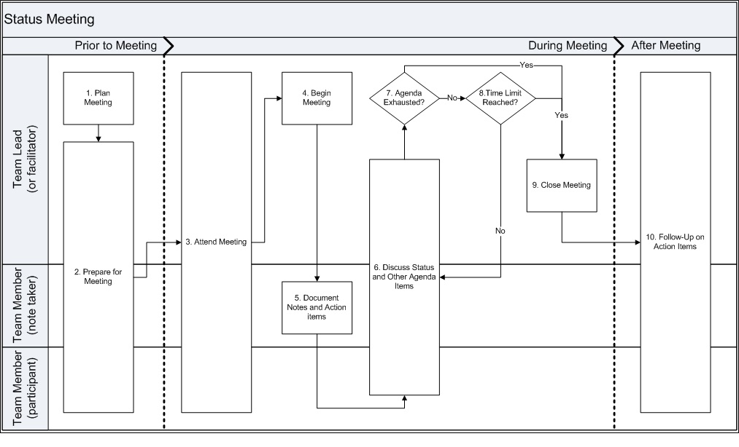

## Activity Instructions

|  |  |  |
| --- | --- | --- |
| **Step** | **Primary Role** | **Detail** |
| ***1.0 Plan Meeting*** | | |
| 1.1 Identify meeting objectives | Team Lead  (or Meeting Facilitator) | Consider what specific, measurable, achievable, and relevant goals need to be reached within the timeframe allotted for the meeting.  The status meeting provides an opportunity to share successes and identify any concerns or challenges that have arisen. The status meeting is often where you will identify the need for a further meeting to pull in additional individuals in order to solve a problem or make a decision. |
| 1.2 Determine frequency of meetings | Team Lead  (or Meeting Facilitator) | Determine (based on the needs of the team):   * Will the team meet daily? * Will the team meet at the predefined times set by the project plan?   The frequency the team meets can be balanced with one-on-one informal status gathering between the Team Lead and each team member. |
| 1.3 Determine meeting location | Team Lead  (or Meeting Facilitator) | Determine (based on the needs of the team):   * Are conference rooms available? * Can the meeting take place in the main work area?   Depending on the facilities, it may necessary to meet in 'public areas' or the main work area. Please be mindful of those in the surrounding area when you meet and the likelihood of distractions (e.g. TVs, lack of sufficient seating or space) that can also impact the productivity of the meeting. |
| 1.4 Determine meeting time | Team Lead  (or Meeting Facilitator) | Determine the best meeting time, taking the following into consideration:   * Would it be best to meet regularly during the morning or afternoon consistently? This helps to keep the team in a routine on getting ready to provide their status and performing individual work planning. * Should team status meetings be scheduled some time after (e.g. 1 hour) new activities are started by the team? This will give the team time to get acclimated with the new activities, figure out questions, and reduce excessive questions that can dominate the meeting. |
| 1.5 Determine roles of team members in meetings | Team Lead  (or Meeting Facilitator) | Questions to consider when assigning team members to meeting roles:   * Who will be facilitator of the meeting? The Team Lead may take on this role early on, but the role can be rotated to other team members that feel confident and are broadly knowledgeable about the state of the project and the team’s work. * Who will be note taker in the meeting? It is recommended, if possible, to rotate this role (and all others) across the team to give experience as well as encourage full team engagement and participation. * Who will be the timekeeper? It is not necessary to have a separate person to play this role, but it can be done if needed. The Team Lead should work with the timekeeper to determine key times when certain portions of the meeting should be completed. Devise a system to silently communicate when time is close to, at the end of, or has exceeded the prescribed time limit for portions of the meeting or the meeting itself.   Once known, notify the team members of the roles that they will be expected to play (beyond meeting participant) during the meeting. |
| ***2.0 Prepare for Meeting*** | | |
| 2.1 Prepare agenda for meeting | Team Lead  (or Meeting Facilitator) | When preparing meeting agenda keep in mind:  1. Put higher priority items toward the top of the agenda. 2. Make sure to keep the agenda as concise as possible. |
| 2.2 Determine other attendees for meeting | Team Lead  (or Meeting Facilitator) | Determine if management needs to attend this particular meeting. (Management may make an appearance as an observer or participant.) |
| 2.3 Communicate meeting logistics to attendees | Team Lead  (or Meeting Facilitator) | Once all the prerequisites (e.g. pre-reads) are prepared and the agenda is completed, send a meeting invite to the team. Be sure to:  1. Only send what is required to the participants. 2. Give sufficient time for the participants to review the pre-requisites and prepare. |
| 2.4 Complete prerequisites for meeting | Team Members | For status meetings:   * Be sure to complete the individual portion of the status report. Make sure to accurately provide the metrics required (e.g. ETC and % complete) and complete other required prerequisites. See the 'Recommended Metrics' section within this document for more details. * Be sure to document any issues you are currently working on and highlight any that require escalation (make these for the attention of management). See the 'Hints and Tips' tab within this document for more details and recommendations.   For any another type of meeting:   * Be sure to review and complete the necessary tasks described by the documents sent along with the agenda to understand what is needed for the meeting (e.g. ideas for completing a change request). |
| ***3.0 Attend Meeting*** | | |
| 3.1 Gather prerequisite materials needed for meeting | Team Members | If a team member is the note taker, bring the required pre-requisites for all team members, and bring appropriate resources to record notes/minutes (e.g. pad and paper, a copy of the agenda with enough whitespace for note taking). |
| 3.2 Go to meeting location | Team Members | Be sure to get to the meeting a few minutes early. |
| ***4.0 Begin Meeting*** | | |
| 4.1 Greet all meeting attendees | Team Lead  (or Meeting Facilitator) | Welcome everyone to the meeting. |
| 4.2 Briefly summarize the goals of the meeting | Team Lead  (or Meeting Facilitator) | Quickly highlight the goals of the meeting in the context of the agenda items. Specifically, where decisions hope to be reached, where issues, risks and other action items require owners, and other critical items for the team. |
| ***5.0 Document Notes and Action Items*** | | |
| 5.1 Document the highlights of the meeting objectively. | Note Taker | The note taker can document the meeting highlights directly on the agenda itself using shorthand and/or use the four-quadrant method (review the ‘Productive Meetings’ pro skills presentation for details). The note taker should be diligent in noting the topics discussed, questions asked, decisions reached and action items to be completed.  See the 'Meeting Minutes Guidelines' section in this document for more tips and best practices in writing meeting notes. |
| 5.2 Review any unclear items with facilitator | Note Taker, Team Lead (or Meeting Facilitator) | If there are any items that the note taker is unsure of, or has an incomplete record of, the meeting facilitator should be notified as soon as possible to correct.   A symbol (e.g. asterisk) can be used as a placeholder for where questions (and possible gaps in the notes) exist and the note taker can continue to write notes on the current discussion.  Once the opportunity arises, the note taker should address the gaps in the notes with the facilitator by quickly referring back to the notes that contain the placeholder. |
| ***6.0 Discuss Status and Other Agenda Items*** | | |
| 6.1 Deliver status | All team members | Facilitator will go around each team member and request their individual status, issues (resolved and unresolved), and any risks associated with tasks or deliverables discussed in the status.  The note-taker will document the information provided in a summary form. |
| 6.2 Provide feedback from status (if required) | All team members | Where appropriate, questions should be asked to better understand the issues or risks discussed in the status.   If possible, propose possible solutions or workarounds. Make sure to have a sufficient understanding prior to making any recommendations.  If the issues or risks are not resolved in this meeting they should be documented in the appropriate log and also in the meeting notes. |
| 6.3 Discuss Meeting Agenda Items | All team members | Facilitator will introduce each topic and its latest status. Based on the defined protocol (i.e. 'rules of order') the topic is discussed by team members and key points, decisions, and action items are documented by the note taker.   Once the topic has exhausted its allotted time (or a decision is made), then the next topic of priority will be discussed. |
| ***7.0 Agenda Exhausted?*** | | |
| 7.1 Check if any other topics need to be discussed | Team Lead  (or Meeting Facilitator) | If the agenda is completed sooner than expected, some time can be used to bring up topics that are impacting the team (i.e. issues), or will impact the team (i.e. risks) if not addressed. It may be necessary to use the time to understand the topic and any factors surrounding it, then schedule another meeting to address the topic. Prepare to close meeting (go to Step 9.0). |
| ***8.0 Time Limit Reached?*** | | |
| 8.1 Announce meeting time nearing end | Team Lead | Once the meeting time is around 5-10 minutes before expiring, the Team Lead (or timekeeper if there is one) should mention to the group that the meeting time is almost completed.   If sufficient time remains, continue discussing the current topic as needed (go to Step 6.0). |
| 8.2 Wrap up remaining points | Team Members | Final comments should be quickly wrapped up and action items should be documented by the note keeper (continue to step 9.0). |
| ***9.0 Close Meeting*** | | |
| 9.1 Summarize meeting results | Team Lead  (or Meeting Facilitator) | In closing the meeting, the Team Lead should summarize (with help from the note keeper):   * any decisions made * any decisions that remain * any newly discovered risks and issues (noting the owner of these items if one has been determined). If an owner is not determined, it is up to the Team Lead, with support if required, to find and assign one. * any action items that are outstanding (noting the owner of these items if one has been determined). If an owner is not determined, it is up to the Team Lead, with support if required, to find and assign one. |
| 9.2 If required, state when the next meeting is scheduled | Team Lead  (or Meeting Facilitator) | State when the next meeting will be held (if known) and highlight what will be covered. Also inform team members that an agenda will be sent out before the next meeting. Before the next meeting, if desired, ask participants if they wish to:   * add items to agenda * volunteer for meeting roles such facilitator, note taker and time keeper. |
| ***10.0 Follow-Up on Action Items*** | | |
| 10.1 Address action items | All Team Members | All owners of risks, issues and action items should (based on priority) obtain answers, workarounds, points, 'show stoppers' or any other feedback. This will help address, mitigate or escalate the items that are assigned to them at or before the designated due time. |
| 10.2 Reach out for status of action items | Team Lead | Where appropriate, the Team Lead should reach out to the appropriate owner of a priority item to determine the status and determine what course of action should be taken next. |
| 10.3 If needed or recommended, solicit feedback on meeting | Team Lead | The Team Lead should gain feedback from some of the attendees on the effectiveness or productiveness of the meeting. Some techniques for gathering feedback are:  1. + (strengths) and ∆ (changes to consider). 2. Start (what is not being done in the meeting that should be done), Stop (what is being done in the meetings that should be stopped), and Continue (what are the positive things that are occurring in the meeting that should be continued). |

## Meeting Minutes Guidelines

The purpose of taking meeting minutes is to document and summarize key meetings conducted on the project. Meeting minutes serve several purposes:

* Inform individuals who were not present at the meeting
* Facilitate follow-up action on critical decisions and open issues
* Once approved by the members, provide the official record of what took place in a meeting

When creating meeting minutes, keep in mind the following guidelines:

* Follow a standard format for meeting minutes across the engagement; a consistent format helps with efficiency in writing and reading the minutes.
* Store the meeting minutes in a common location, and name the files consistently.
* Include the following information in the meeting minutes:
  + Name of the person who is preparing the minutes; this provides a source for clarification of the discussion or intent
  + Date and time of the meeting
  + Meeting participants
  + Key discussion points from the meeting, listed and numbered
  + Decisions reached
  + Action items including who is responsible for the action and an assigned due date
* Start documenting the meeting minutes by inserting the main topics from the meeting agenda.
* Write meeting minutes clearly and concisely so it is easy to determine what took place at a meeting.
* Write up and distribute the meeting minutes on the day the meeting is held, but no later than the end of the next business day.

Meeting minutes should not:

* Be a verbatim record of what was said at the meeting.
* Be fragmented, repetitive, and unorganized.
* Use subjective language or state the author’s opinions.
* Misrepresent the facts.

## Recommended Metrics

A metric is the measurement of attributes that allows comparison or prediction of a process or a product.

For the team, depending on the work that is being done and the work products being completed, metrics can be used to track these deliverables effectively. Of the many metrics that are available in the team status report, consider using just a 'vital few'. Two of the more popular metrics are detailed below:

* **Estimated Time to Complete (ETC)** - The amount of time needed to complete the task based on performance to date. This is a number (typically in hours) to state the amount of time needed to complete the task/activity. If you need to provide an ETC greater than what is remaining, prepare to explain the rationale and seek assistance for your lead on how to complete the tasks timely
* **Percentage Complete (% Complete)** - How much of the work product is completed. The following are common percentage ranges that can be used:
  + 0% Not started
  + 1 - 19% Initial Review in progress
  + 20% Document of requirements initially reviewed and understood
  + 21 - 59% Initial Draft in progress
  + 60% Initial Draft complete
  + 61 - 69% Self Review in progress
  + 70% Self Review complete
  + 71 - 89% Peer Review in progress
  + 90% Peer Review complete
  + 91 - 99% Lead Review in progress
  + 100% Lead Review complete

## Hints and Tips

**Estimating**

When estimating, it is important to be as accurate as possible. It can be a challenge early on to estimate correctly so getting support on this will help you a great deal and remember, the more you work on a task the better your estimations will be.

Keep in mind that estimates go into the plan in order to determine:

* what work will be assigned next
* the impact it will have on the team or project in achieving its delivery dates
* if other resources need to get involved to help complete the task

When providing an estimate, be prepared to explain the rationale behind your time estimation (whether it's earlier or later than expected).

**Big Picture**

As a member of a team you are critical to the success of the project and, to be a success, everyone must trust in the other to complete their portion of the work required.

With this in mind, it is extremely important that when providing status you are honest. If you are behind or ahead then say so and provide what steps you have taken prior to this point. This will give the Team Lead some time to think about how to adjust priorities so they can get help for you or give you the next task to perform to help the team.

Follow the normal escalation pattern when stuck in a task:

1. Take some to solve it yourself through research,
2. Get a team mate to help,
3. Ask the Team Lead.
4. If your team can't figure out a solution to the problem then seek the assistance of members from other teams,
5. Reach out (“Escalate”) to the management for assistance.